***WALEED KHAN***

***ADDRES:*** CAA COLONY AIRPORT KARACHI NEAR MADINA MASJID H51 HOUSE NUMBER

***(CONTACT NUMBER:*** ) - 03032211915

# Objective;

Secure a responsible career opportunity to fully utilize My Training and Skills While making a significant contribution to the success of the company

***PERSONAL INFORMATION:***

**Father name:**  AJMAL KHAN

**Date of birth:** 27 october,2003

**Place of birth:**  Karachi

**Nationality:**  Pakistan

**CNIC:** 42201-5831994-1

**Religion** Islam

**Marital status:** Single

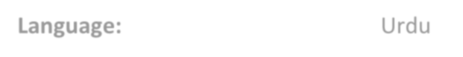

**Language:**

Urdu



***EDUCATION:***



I

ntermediate

(

computer science

)



Board of intermediate K

arachi



M

atriculation

(

computer science

)



Board

of secondary education K

arachi



|  |
| --- |
|  |
|  |

* : Ms office
* : DIT
* MS EXCEL

**STUDY:DOING BS : SOFTWARE ENGINEERING FROM SMIU**

## WORK EXPERIENCE;

1 : MYJISTIC AIRLINE : AS A WORKER

## REFERENCE

Will Be Furnished on demand